

**Pinterest**

21-3-2020

**─**

Habiba Khaled Mohamed Mahmoud sec(6)

Dina Abdallah said Ahmed sec(7)

Alaa Mohamed Mostafa Kamel sec(4)

Alaa Mahmoud Mohamed Abdulaziz sec(4)

Youssef Tarek Abd El-Aziz Ali sec(20)

1- ERD

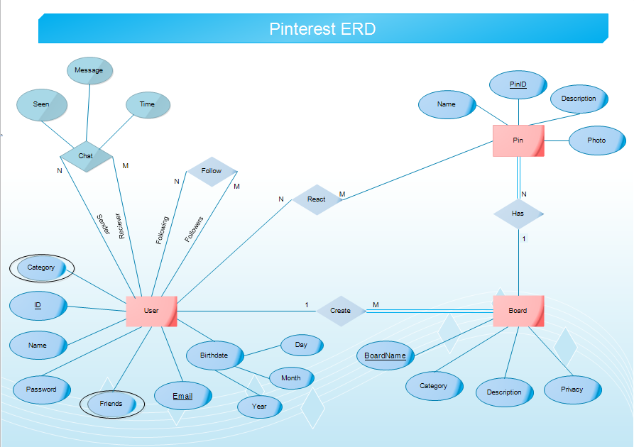

2- Assumptions

Mainly, a pin is a photo, a board is a collection of pins.

**User’s Attributes:**

* Each user has a unique email, and unique ID.
* Each user has multiple friends, and multiple board categories he/she chooses.
* Each user has a detailed birthdate (year-month-day).
* User’s name isn’t detailed (ie. not in first name - last name form), it’s saved as a whole as a single string.

**Board’s Attributes:**

* A board has a unique name.
* It also has a category (ex: music / art ..).
* It has a description, and a privacy value (ie. public or private) that allows the user to share it with others or not.

**Pin’s Attributes:**

* A pin has a unique ID.
* It has a description and a name.
* It has a photo uploaded by the user or saved from a public board created by any other user.

**Relations:**

* Each user can create more than a board, while each board belongs only to one user.
* Each board can have more than a pin, while each pin belongs only to a single board.
* Each user can chat with more than a friend on pinterest with messages at specific times and view if messages are read or not (seen attribute).
* An User can chat only with friends.
* Each user can follow many people and has many followers.
* Each user reacts on many pins .
* Each pin has many emoji from many users.

3- Schema Relations :

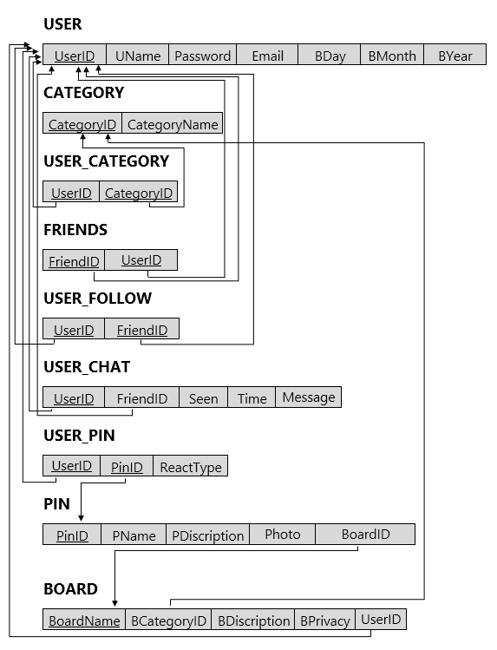

4- Screen shot for tables created in Oracle:

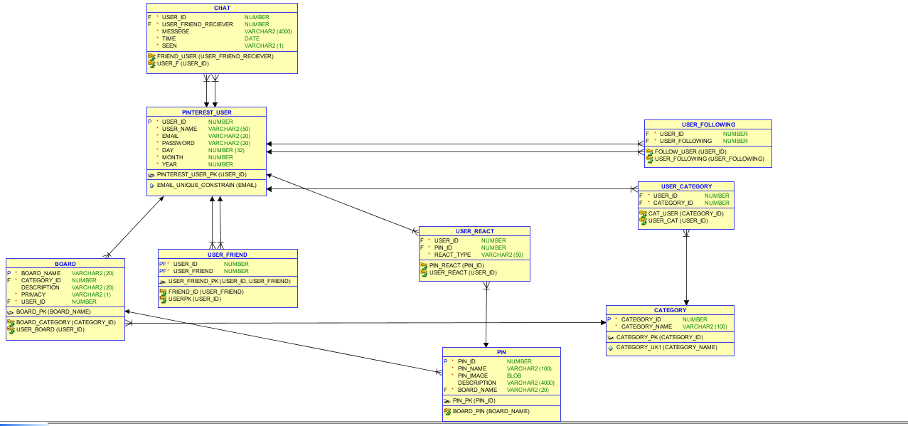

* Details of All tables as over all :-

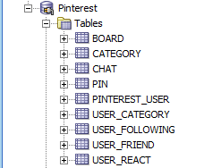

1. Pinterest_User :

* In Oracle Hierarchy:

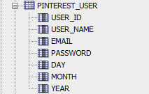

* User Columns:

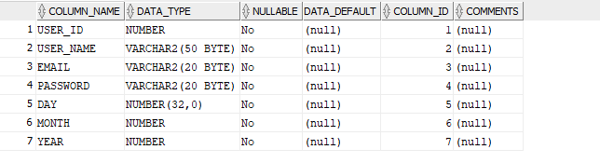

* User Data First Look:

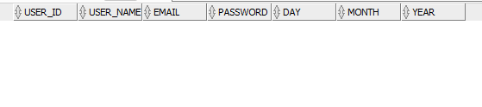

* User Constraints :

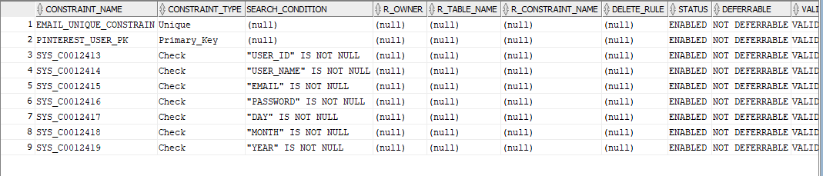

* User DDL:

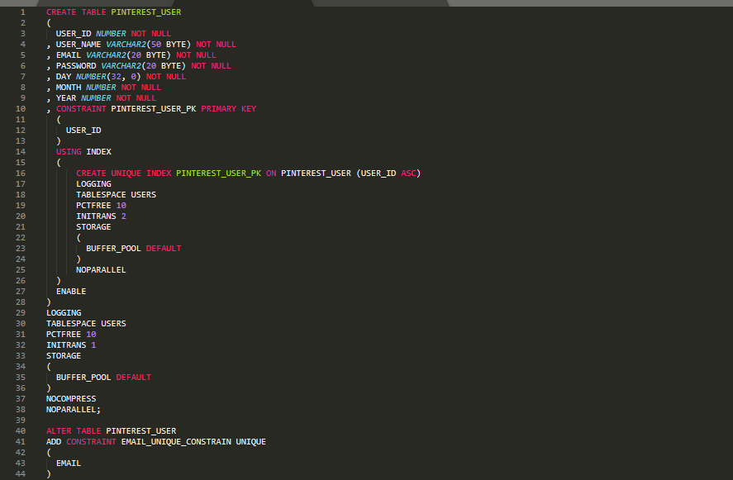

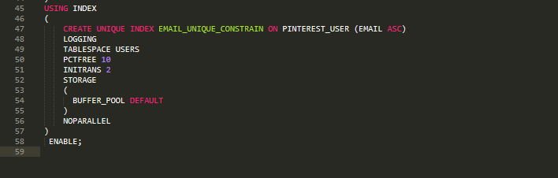

1. Board:

* In Oracle Hierarchy:

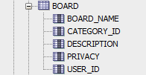

* Board Columns:

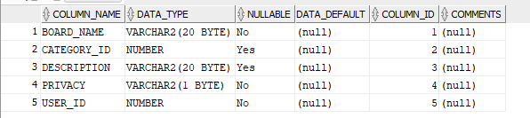

* Board Data First Look:

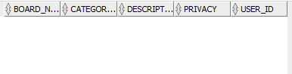

* Board Constraints :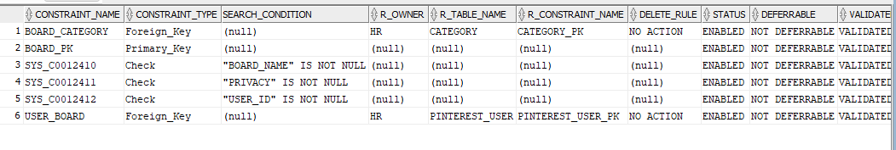
* Board DDL:

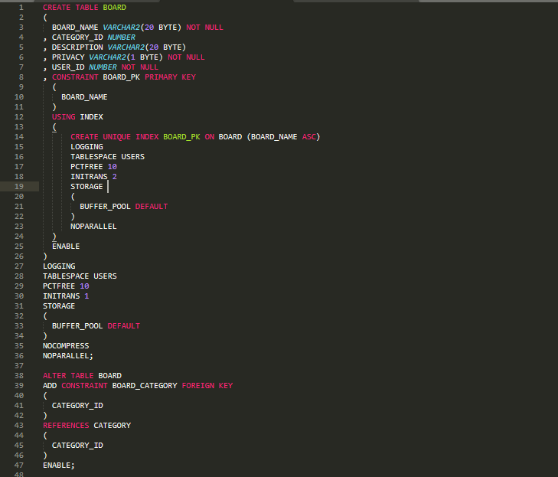

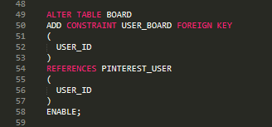

1. Pin :

* In Oracle Hierarchy:

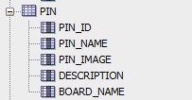

* PIN Columns:

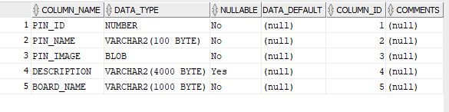

* PIN Data First Look:

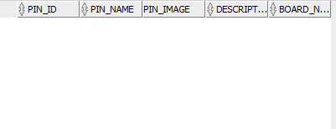

* Pin Constraints :

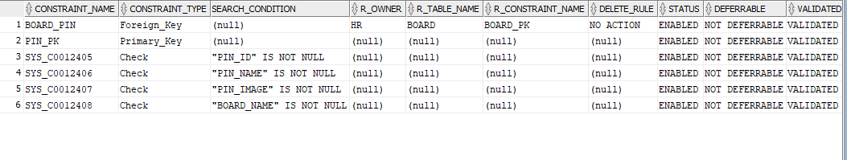

* Pin DDL:

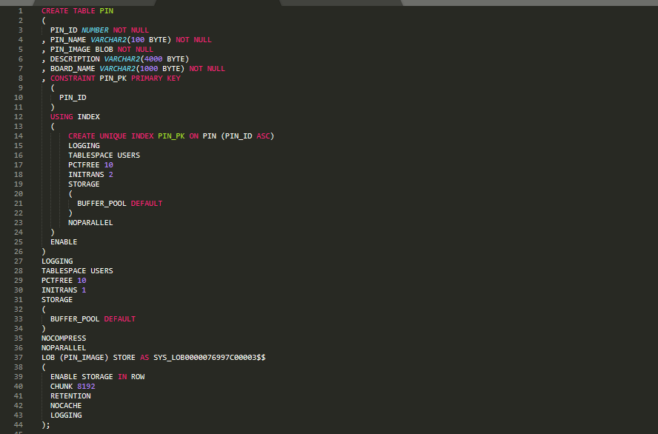

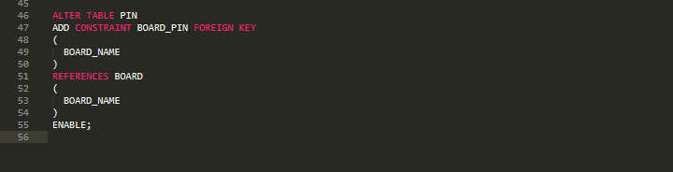

1. Category:

* In Oracle Hierarchy:



* Category Columns:

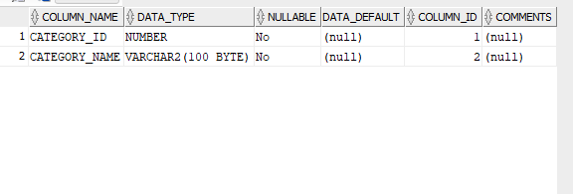

* Category Data First Look:

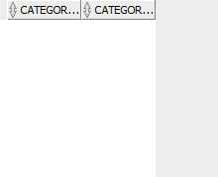

* Category Constraints :

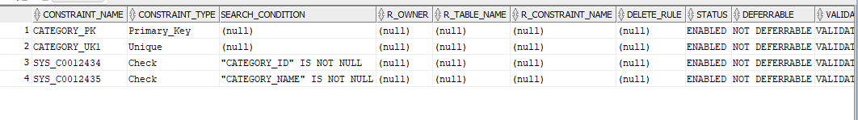

* Category DDL:

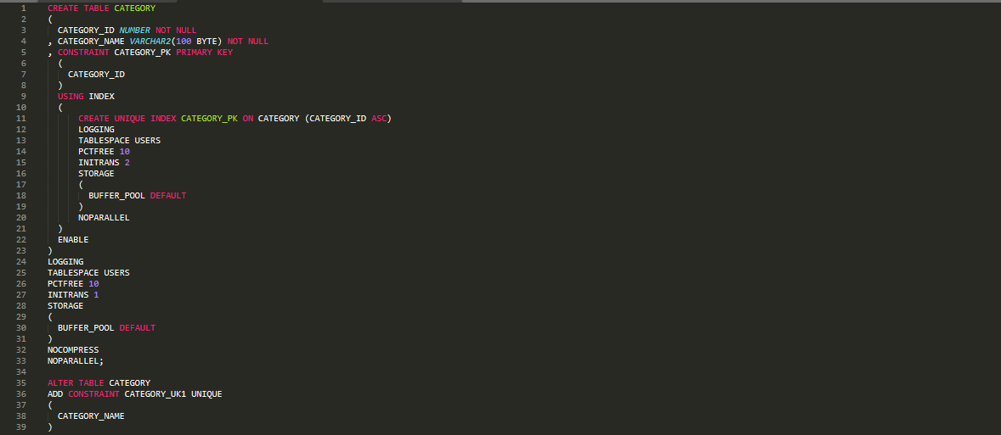

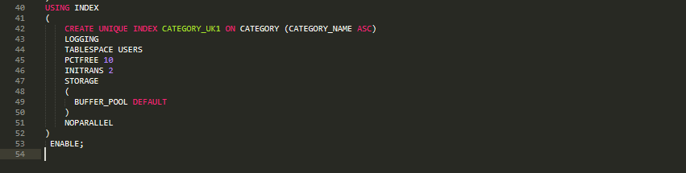

1. Chat :

* In Oracle Hierarchy:

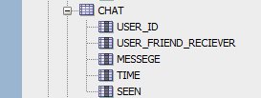

* Category Columns:

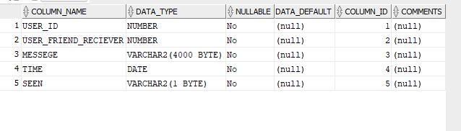

* Category Data First Look:

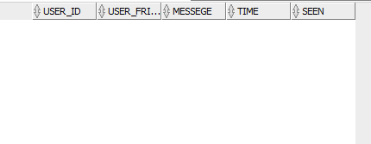

* Category Constraints :

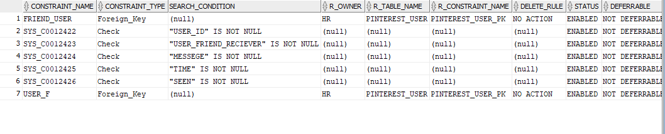

* Category DDL:

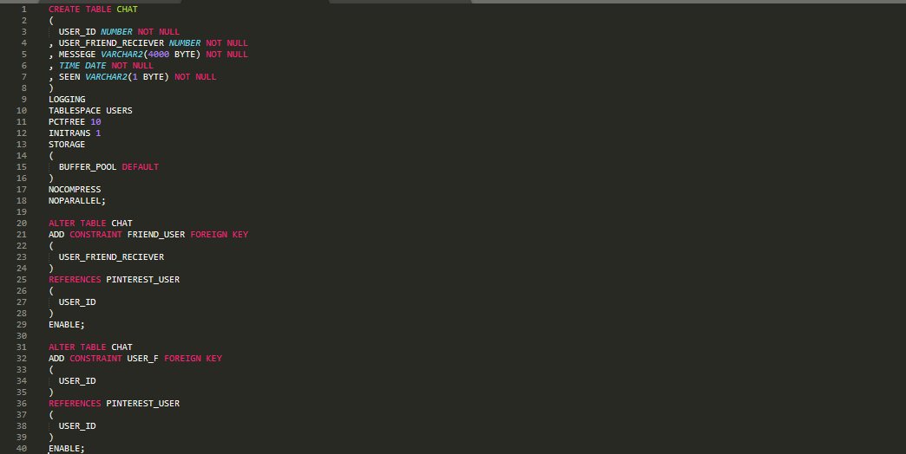

1. User_Category:

* In Oracle Hierarchy:



* User_Category Columns:



* User_Category Data First Look:



* User_Category Constraints :



* User_Category DDL:



1. User_React:

* In Oracle Hierarchy:

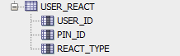

* User_React Columns:

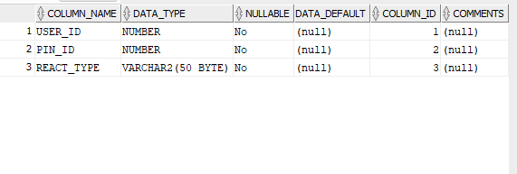

* User_React Data First Look:

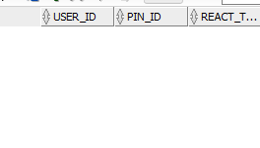

* User_React Constraints :

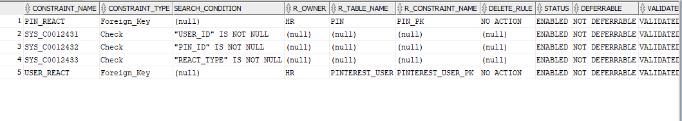

* User_React DDL:

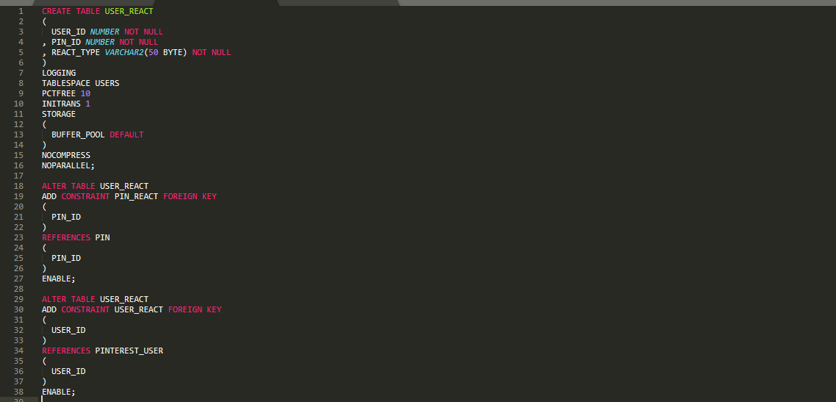

1. User_Friend:

* In Oracle Hierarchy:



* User_Friend Columns:

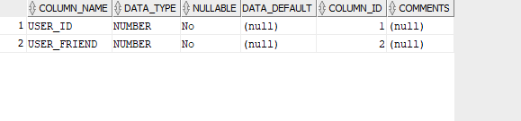

* User_Friend Data First Look:

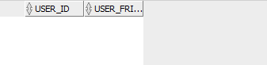

* User_Friend Constraints

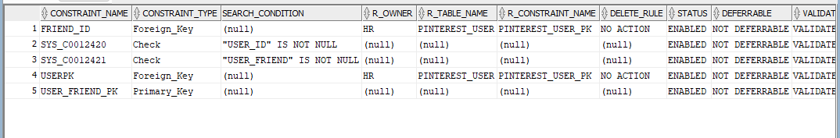

* User_Friend DDL:

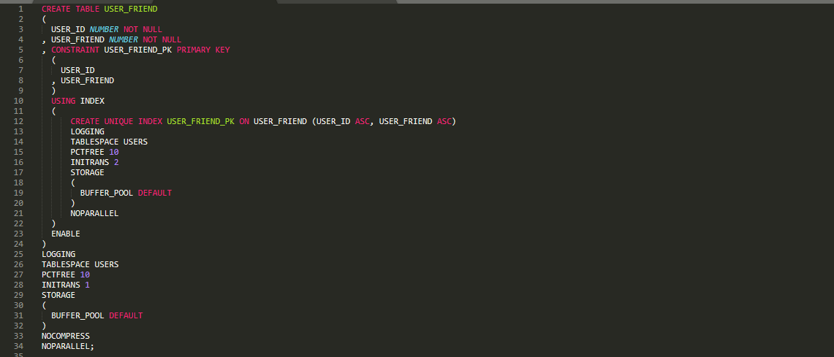

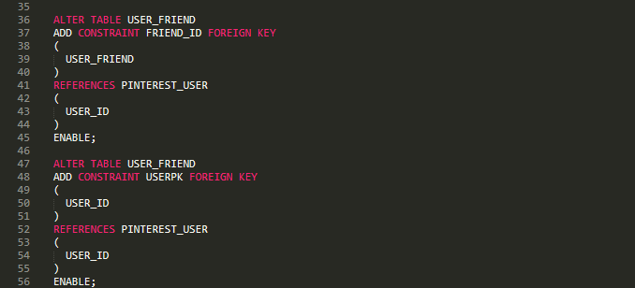

1. User_Following:

* In Oracle Hierarchy:



* User_Following Columns:

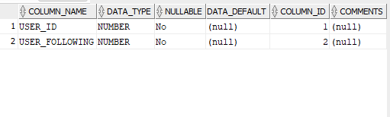

* User_Following Data First Look:

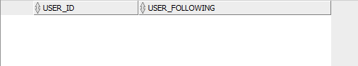

* User_Following Constraints

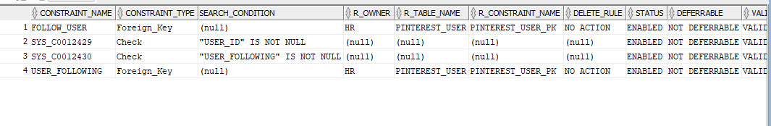

* User_Following DDL:

